## **Brand Name:**

RankFusion UMD – Ramyakoumudi Kaveri, Jayanth Sankar, Adit Pawar, Rohit Sangem

**Mission Statement:**

Compile and present multi-year rankings of UMD Smith School's graduate programs from various credible sources for analysis by the Dean and faculty to assess program positioning and aid strategic decision-making.

## **Mission Objectives:**

* Identify multiple data source websites for UMD Smith School program rankings.
* Collect program rankings and necessary details annually from these data sources.
* Determine the top-ranking programs from various data sources.
* Acquire acceptance rates, student diversity, and scores for top-ranked programs.
* Identify and work on improving the ranking of lower-ranking UMD Smith School programs.

## **Business Terms & Definitions:**

* **Program:** UMD Smith School's specific academic programs.
* **Faculty:** Individuals in teaching or administrative roles within programs.
* **Ranking:** Evaluation of program performance or quality based on various criteria.
* **DataSource:** Sources providing program ranking information.
* **Applicant:** Individuals applying to UMD Smith School programs.

## **Entities, Attributes and Primary Keys**

Program (**progId**, progName, progDesc, progAcceptancerate, progCareeroutcome, progAvgsalary)

Faculty (**facId**, facName, -facFirstName, -facLastName, facProgram, facSupervisor, facRole)

DataSource (**dsId**, dsName, dsURL, dsRankscore, dsRankdesc, dsRankyear)

Applicant (**applicantId**, progId, applicantsYearly, applicantsAcceptance, applicantsGREscore, applicantsStudenttype, applicantReview)

## **Relationships, Attributes, Degrees, Participating Entities and Constraints**

Work: Binary relationship

1 program to 1 or many faculties

1 faculty to 1 or many programs

Rank: Binary relationship

1 program to 1 or more datasource

1 datasource to 1 or more program

Apply: Binary relationship

1 program to 0 or many applicants

1 applicant to 1 or many programs

Manages: Unary relationship

1 supervisor to 0 or more faculty

1 faculty to 0 or 1 supervisor

# **ER Diagram:**

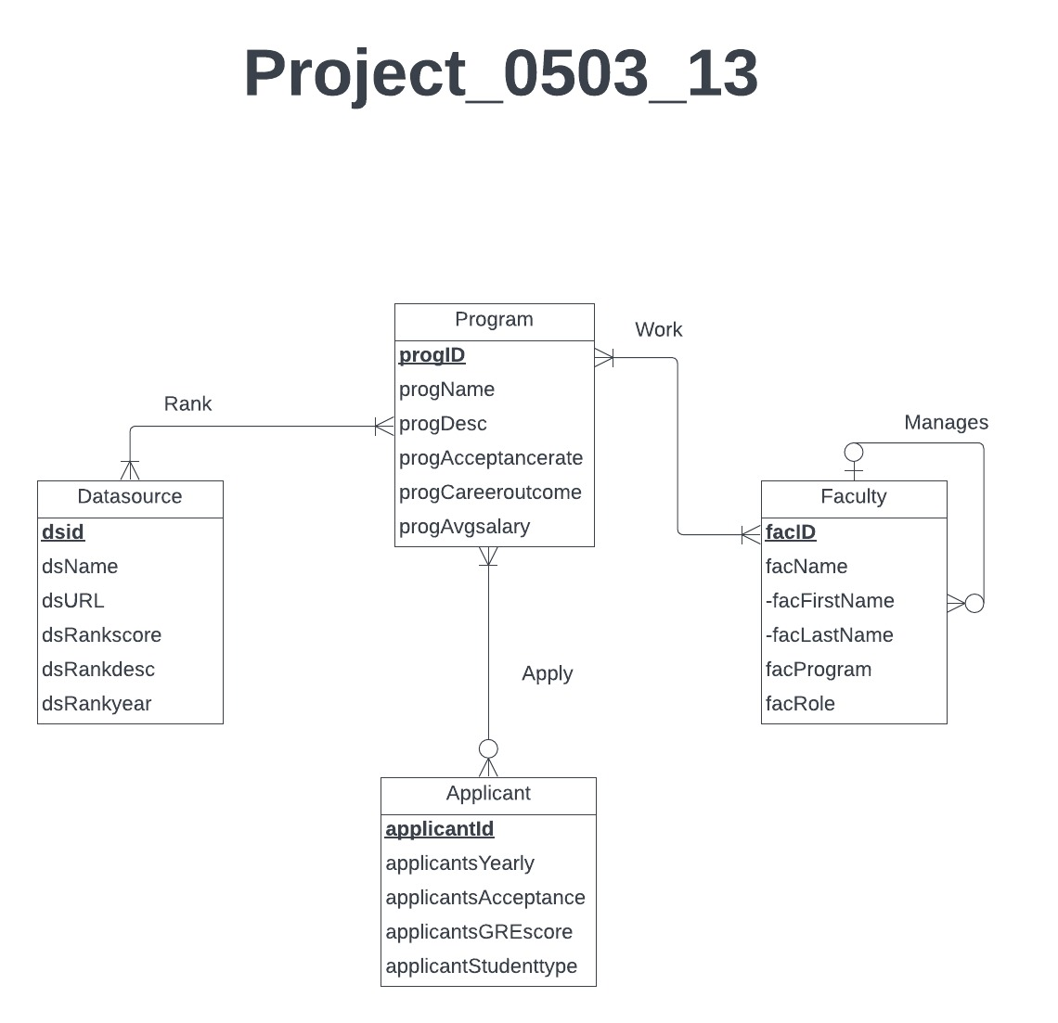

# **Relations:**

Program (**progId**, progName, progDesc, progAcceptancerate, progCareeroutcome, progAvgsalary)

Faculty (**facId**, ***progid***, facProgram, facSupervisor, facRole)

DataSource (**dsId**, ***progid***,dsName, dsURL, dsrankScore, dsRankdesc, dsRankyear)

Applicant(**applicantId**, ***progid***, applicantsYearly, applicantsAcceptance, applicantsGREscore, applicantsStudenttype)

# **Functional Dependencies:**

progId → progId, progName, progDesc, progAcceptancerate, progCareeroutcome, progAvgsalary

facId, progId → facProgram, facSupervisor, facRole

dsId, progId → dsName, dsURL, dsrankScore, dsRankdesc, dsRankyear

applicantId, progId → applicantsYearly, applicantsAcceptance, applicantsGREscore, applicantsStudenttype

# **Business rules:**

[R1]When a program is removed from school or deleted, set the progId in the corresponding faculty records to NULL in the database.

[R2]When the progId in a program record is updated, update the corresponding progId in the associated faculty records subsequently.

[R3]When the program is removed from school or deleted, set the progId in the corresponding data source records to NULL in the database.

[R4] When the progId in a program record is updated, update the corresponding progId in the associated data source records subsequently.

[R5]When a program is removed from school or deleted, set the progId in the corresponding applicant records to NULL  in the database.

[R6] When the progId in a program record is updated, update the corresponding progId in the associated applicant records subsequently.

**Referential integrities:**

|  |  |  |  |  |  |  |  |
| --- | --- | --- | --- | --- | --- | --- | --- |
| Relation | Foreign Key | Base Relation | Primary Key | Business Rule | Constraint: ON DELETE | Business Rule | Constraint: ON UPDATE |
| Faculty | progId | Program | progId | R1 | SET NULL | R2 | CASCADE |
| Data  Source | progId | Program | progId | R3 | SET NULL | R4 | CASCADE |
| Applicant | progId | Program | progId | R5 | SET NULL | R6 | CASCADE |